**Customer Requirement Specifications (CRS)**

***Human Resource (HR) Module***

***For***

***ERP Solution for Samuda Chemicals Ltd.***



**Genweb2 Limited**

TK Bhaban (11th Floor),

13 KaziNazrul Islam Avenue,

Kawran Bazar, Dhaka 1215, Bangladesh

web: [http://www.genweb2.com](http://www.genweb2.com/)

1. Document Information

|  |  |
| --- | --- |
| Document Name | HR Module of Samuda Chemicals Ltd. (CRS) |
| Document Author |  |
| Document Objective |  |
| Document Owner |  |
| Document Location |  |
| Document Version | 1.0 |
| Release Date |  |

|  |  |
| --- | --- |
| Review by |  |
| Review Date |  |
| Approved By |  |
| Approval Date |  |

1. Document History

|  |  |  |  |  |  |
| --- | --- | --- | --- | --- | --- |
| A=Added, M=Modified, D=Delete | | | | | |
| **Version No** | **Date** | **Section No** | **A/M/D** | **Description of Change** | **Author** |
| 1.0 | 08-Jan-2017 |  |  | Approved version |  |
|  |  |  |  |  |  |
|  |  |  |  |  |  |

**Contents**

A. Document Information 2

B. Document History 3

**1.0** **Introduction** 5

**1.1 Purpose of CRS** 5

**2.0** **HR Module Overview** 5

**3. Sub Module and Its feature Description** 7

**3.1 Employee Personal Information** 7

**3.2 Define Organization Calendar** 7

**3.3 Leave management** 7

**3.3.1 Module Overview** 7

**3.3.2 Leave Type Declaration** 7

**3.3.3 Declare Leave Year:** 8

**3.3.4 Leave Allocation Process** 8

**3.3.4 Leave Approval Process** 8

**3.3.5 Leave Carry Forward** 9

**3.3.6 Leave Encashment Process** 10

**3.3.7 Short Leave Process** 11

# **Introduction**

# **1.1 Purpose of CRS**

The purposes of this CRS (Customer Requirement Specification) are to clearly identify the customer requirements and provide a detailed document. The customer will review the document and approve/make changes as required. It will also help the review team to validate whether the customer requirements has been fulfilled or not.

# **HR Module Overview**

We often hear the term Human Resource Management, Employee Relations and Personnel Management used in the popular press as well as by Industry experts. Whenever we hear these terms, we conjure images of efficient managers busily going about their work in glitzy offices.

The first definition of HRM is that it is the process of managing people in organizations in a structured and thorough manner. This covers the fields of staffing (hiring people), retention of people, pay and perks setting and management, performance management, change management and taking care of exits from the company to round off the activities. This is the traditional definition of HRM which leads some experts to define it as a modern version of the Personnel Management function that was used earlier.

The second definition of HRM encompasses the management of people in organizations from a macro perspective i.e. managing people in the form of a collective relationship between management and employees. This approach focuses on the objectives and outcomes of the HRM function. What this means is that the HR function in contemporary organizations is concerned with the notions of people enabling, people development and a focus on making the “employment relationship” fulfilling for both the management and employees.

There is a need to align organizational goals with that of the HR strategy to ensure that there is alignment of the people policies with that of the management objectives. This means that the HR department can no longer be viewed as an appendage of the firm but instead is a vital organ in ensuring organizational success.

The aims of module are to provide the organization with a sense of direction and a feeling of purpose. The days when the HR manager was concerned with administrative duties is over and the current HRM practices in many industries are taken as seriously as say, the marketing and production functions.

**Importance of HRM**

The practice of HRM must be viewed through the prism of overall strategic goals for the organization instead of a standalone tint that takes a unit based or a micro approach. The idea here is to adopt a holistic perspective towards HRM that ensures that there are no piecemeal strategies and the HRM policy enmeshes itself fully with those of the organizational goals. For instance, if the training needs of the employees are simply met with perfunctory trainings on omnibus topics, the firm stands to lose not only from the time that the employees spend in training but also a loss of direction. Hence, the organization that takes its HRM policies seriously will ensure that training is based on focused and topical methods.

In conclusion, the practice of HRM needs to be integrated with the overall strategy to ensure effective use of people and provide better returns to the organizations in terms of ROI (Return on Investment) for every rupee or dollar spent on them. Unless the HRM practice is designed in this way, the firms stand to lose from not utilizing people fully. And this does not bode well for the success of the organization.

New information technologies and their services have significantly improved the cost-efficiency and lowered the execution risks of human resource management systems. Those technologies and services include human resource, payroll system, attendance, software system as a service (SaaS) and integrative company management systems like enterprise resource coming up with software (ERP).

This specific module will help **Samuda Chemicals Ltd.** to manage its HR Department’s serious and cumbersome workloads in most efficient way. The HR department performs body activities that are virtually common to all or any organizations. To change the HR workflows convenient and easy this modules will perform all the HR activities which are designed for a specific organization. All of these sub modules have their distinctive functions and have efficiencies to perform their respective jobs.

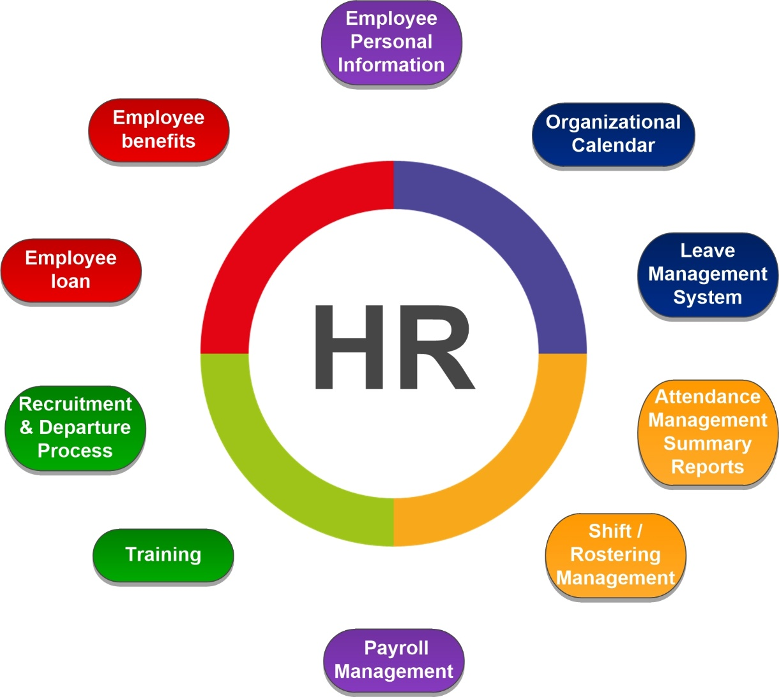

**Fig:** HR module and its Sub-modules

The following are the Sub modules of HR module is given below:

1. **Employee Personal Information**
2. **Org. Calendar**
3. **Leave Management**
4. **Attendance Management**
5. **Shift / Roster Management**
6. **Payroll Management**
7. **Training**
8. **Recruitment & Exit Process**
9. **Employee Loan**
10. **Employee Benefits**

# **3. Sub Module and Its feature Description**

## **3.1 Employee Personal Information**

This module will maintains all relevant employee related information‚ including different types of personal information‚ detailed qualifications and work experience‚ job related information etc. A picture of the employee can be added as well. All documents related to the employee can be scanned and attached to contribute to legally compliant record keeping. Information captured in this module is utilized by all other modules thus eliminating data redundancy. This will be only accessible by individual and Authorized HR user.

## **3.2 Define Organization Calendar**

This will prepare an organization calendar every year by mentioning public holidays and week holidays. This calendar is prepared by authorized HR Personnel.

## **3.3 Leave management**

### 

### **3.3.1 Module Overview**

Leave management module is responsible to track all the employees’ leave related activities. It will help to declare leave types along with leave encashment and carry forward feature. This module will also have dynamic leave approval system for the applied leave by the employee. Features of this sub module is given below:

### **3.3.2 Leave Type Declaration**

Employees across all industries are entitled to a certain number of leaves per year aside from the holidays and days off. The number and type of leave depends on the industry, employer. Three types of leaves are generally found named earned leave, sick leave and casual leave which an employee can avail without loss of pay.

* + **Casual leave** is provided to take care of urgent and unseen matters like child has fallen down in school and you get call from school. For example: At Samuda employees can avail 13 days of casual leave yearly. It is configurable by Authorized HR Manager.
  + **Sick leave** is provided in case of when employee gets sick. For example: At Samuda employees can avail 7 days of sick leave. It is configurable by Authorized HR Manager.
  + **Earned Leave** is provided for planned long leaves for the purpose of travel/ vacation etc. For example: At Samuda, employees can avail 17 days of earned leave which is calculated yearly. At system's setting/configuration it will be declared the type of earned leave i.e. quarterly/yearly etc.

First we need to declare the leave type; casual leave and sick leave within the system. No need to declare earned leave. After declaration of the leave types system needs to tag it with each employees.

### **3.3.3 Declare Leave Year:**

An employer must usually tell their staff the dates of their statutory leave year as soon as they start working, e.g. it might run from 1st January to 31st December. Workers must take their statutory leave during this time. For example: Samuda leave year is January to December.

### **3.3.4 Leave Allocation Process**

Every Leave will be manually allocated except earn leave. Earn leave will be allocated end of year and employee will avail that next year. It will be system generated. Example: An employee can avail 7 days sick leave in a year. So it indicates sick leave allocation for that employee is 7 days which will be entertained throughout the year. Leave allocation can be done employee wise/department wise or for all employee.

### **3.3.5 Leave Approval Process**

Leave process can have multi-layer approval process. For example, after applying the leave application goes to line manager. Then after approval of line manager it will go to the head of the dept. for the final approval. The application can be rejected on both line manager and head of the department stage. At Samuda leave approval process will have two steps i.e. approval of line manager and department head.

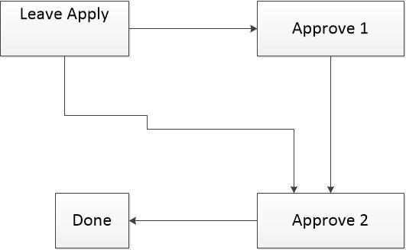

**Fig:** Leave Approval Process

### **3.3.6 Leave Carry Forward**

Earned Leave will be carry forward to next year if it meets the required criteria and added on users corresponding leave type. Process of earned leave carry forward is very simple:

First we need to check if user is eligible to carry forward his leave or not. For example, available leave has to be minimum of 5 days to be forwarded and user will be eligible. Then we check if user wants to carry forward his leave or not along with the carry forward leave type checking of yearly/quarterly etc. After user decides to carry forward his leave then we will have to generate eligible user list for leave carry forward. Also the multi-layer approval should be there to process it.



**Fig:** Leave carry forward and encashment Process

### **3.3.7 Leave Encashment Process**

In case an employee does not avail earned leaves which were allowed to him, he may also encash these leaves and earns salary for the number of days which were allowed to be taken as leave but were not availed as leave. The policy of leave encashment depends on the employer for whom you are working and different employers have different policies for leave encashment.

First we need to check if user is eligible to carry forward his leave or not. For example, available leave has to be minimum of 5 days to be forwarded and user will be eligible. Then we check if user wants to carry forward his leave or not along with the carry forward leave type checking of yearly/quarterly etc. After user decides to carry forward his leave then we will have to generate eligible user list for leave carry forward. Also the multi-layer approval should be there to process it. To get the whole process please see the previous image.

### **3.3.8 Short Leave Process**

Short leave is for up to 3 working days per year for employees to attend matters of a personal and pressing nature that arise with little or no notice and require immediate attention and which cannot be conducted outside of normal business hours. In this module employee needs to apply this for leave and the approval process is given below:



**Fig:** short Leave Approval Process